Optimising Users, Group, Role Management
Team Id: NM2025TMID16265
Team Members:4
Team Leader: DEEPALAKSHMI R.M
Team Member 1 : ESWARI .S
Team Member 2 : JAGADEESHWARI.J
Team Member 3 : ASHWINI.V
Problem Statement : The project focused on optimising the management of users, groups, and roles to enhance system efficiency, security, and scalability. Key responsibilities included streamlining user provisioning and deprovisioning processes, implementing role-based access controls (RBAC), and restructuring
group policies for better access control.
Objective : To design and implement a system that simpliesuser, group, androle management by integrating access control policies andwork owautomation, ensuring secure, efficient, and scalable management of organizational resource
Skills: This project demonstrates strong skills in identity and access management (IAM), focusing on optimizing the administration of users, groups, and roles within an organizational system. It highlights proficiency in access control, role-based access control (RBAC) models, and efficient user lifecycle management.
TASK INITIATION
Milestone 1 : Users
Activity 1: Create Users
- Open service now
- Click on All >> search for users
- Select Users under system security
- Click on new
- Fill the following details to create a new user
- Click on submit
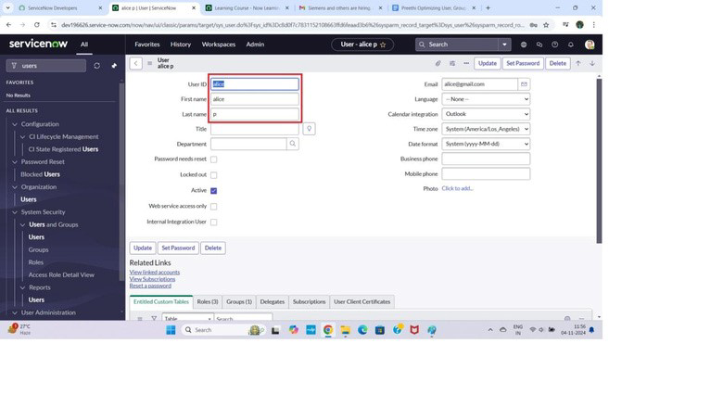
Create one more user:

7.Create another userwiththe following details
8.Click on submit
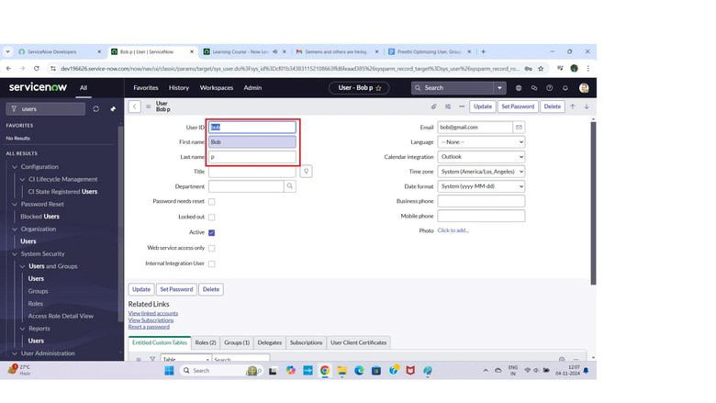
Milestone 2 : Groups
Activity 1: Create Groups
1. Open service now. 2. Click on All >> search for groups 3. Select groups under system security 4. Click on new 5. Fill the following details to create a new group 6. Click on submit
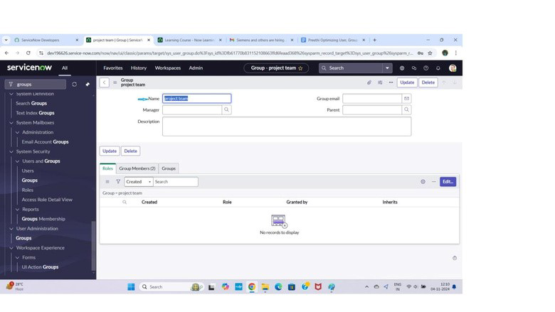
Milestone 3 : Roles
Activity 1: Create roles
- Open service now.
- Click on All >> search for roles
- Select roles under system security
- Click on new
- Fill the following details to create a new role
- Click on submit
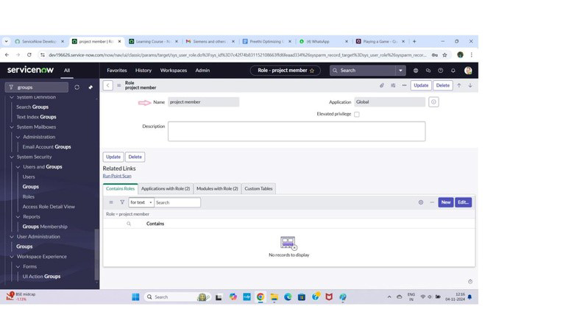
Createone more role:
7.Create anotherrole with the following details
8.Click on submit
Milestone 4 : Table Activity 1: Create Table
  - Open service now.
  - Click on All >> search for tables
  - Select tables under system definition
  - Click on new
  - Fill the following details to create a new table
Label : project table
Check the boxes Create module & Create mobile module
  - Under new menu name : project table
  - Under table columns give the columns
  - Click on submit
Create one more table:
9.Create another table as:task table 2 and fill with following details.
10. Click on submit.
Milestone 5 : Assign users to groups Activity 1: Assign users to project team group
1.Open service now.
2.Click on All >> search for groups 3.Select tables under system definition
4.Select the project team group 5.Under group members
6.Click on edit
7.Select alice p and bob p and save
Milestone 6 : Assign roles to users
Activity 1: Assign roles to alice user
1.Open servicenow.Click on All >> search for user
2.Select tables under system definition
3.Select the project manager user
4.Under project manager
5.Click on edit
6.Select project member and save
7.click on edit add u_project_table role and u_task_table role
8.click on save and update the form.
Activity 2: Assign roles to bob user
1. Open servicenow.Click on All >> search for user
2.Select tables under system definition
3.Select the bob p user
4.Under team member
5.Click on edit
6.Select team member and give table role and save
- Click on profile icon Impersonate user to bob
- We can see the task table2.
Milestone 7 : Application access
Activity 1: Assign table access to application
  - while creating a table it automatically create a application and module for that table
  - Go to application navigator search for search project table application
  - Click on edit module
  - Give project member roles to that application
  - Search for task table2 and click on edit application.
  - Give the project member and team member role for task table 2 application

Milestone 8 :Access control list Activity 1: Create ACL
- Open service now.
- Click on All >> search for ACL
- Select Access Control(ACL) under system security 4. Click on elevate role 5. Click on new
- Fill the following details to create a new ACL
- Scroll down under requires role
- Double click on insert a new row
- Give task table and team member role
- Click on submit
- Similarly create 4 acl for the following fields
12.Click on profile on top right side
13.Click on impersonate user
14.Select bob user
15.Go to all and select task table2 in the application menu bar
16. Comment and status fields are have the edit access

Milestone 9: Flow
Activity1:CreateaFlow to Assign operations ticket to group
- Open service now.
- Click on All >> search for Flow Designer
- Click on Flow Designer under Process Automation.
- After opening Flow Designer Click on new and select Flow.
- Under Flow properties Give Flow Name as “ task table”. 6.
Application should be Global.
7. Click build flow.

next step ::
- Click on Add a trigger
- Select the trigger in that Search for “create record” and select that.
- Give the table name as “ task table ”.
- Give the Condition as Field : status Operator :is Value : in progress
Field : comments Operator :is Value : feedback Field : assigned to Operator :is Value : bob 5. After that click on Done.
Next step:
  - Clickon Add an action.
  - Selectaction in that ,search for “ update records”.
  - In Record field drag the fields from the data navigation from Right Side(Data pill)
  - Tablewill be auto assigned after that
  - Addfields as “status” and value as “completed”
  - Clickon Done.
Next step:
  - Now under Actions.
  - Click on Add an action.
  - Select action in that ,search for “ ask for approval ”.
  - In Record field drag the fields from the data navigation from Right side
  - Table will be auto assigned after that
  - Give the approve field as “ status” 7. Give approver as alice p
8. Click on Done.
9.Go to application navigator search for task table.
10.It status field is updated to completed
11.Go to application navigator and search for my approval 12.Click on my approval under the service desk.
13. Alice p got approval request then right click on requested then select approved
Conclusion
:

